****Bluetooth APP control****

If you want to use Bluetooth remote control, please follow the steps below:

****1.Download code：****

Download the program shown below to the Omibox programming robot.

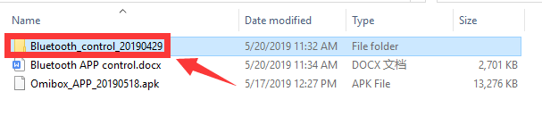Note: If the mobile APP has connected to the Bluetooth of the robot car, the program download will report an error, you need to exit the APP and download the code. (When the Bluetooth of OmiBox is connected, the program may not be downloaded normally.)

For the method of installing Arduino IDE and downloading the program, please refer to the contents of the 【Preparation before class】.

**2. Download Bluetooth Remote APP**

For Android users, please use the browser to scan the QR code to download the APP and install it. Apple users should use the camera to scan the QR code to enter the App Store to download and install the APP.

(For Android users,Please click here to download the APP)

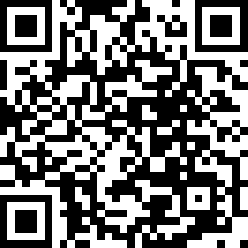

**! ! ! Note: If there is any prompt to obtain permission during the installation, please select [Yes] or [Agree],**

**For example, you need to obtain the geographical location information.**

**2.Connect Bluetooth**

2.1 Open the power of the OmiBox programmable robot. And turn on the Bluetooth of mobile phone, open the Bluetooth APP software. You will see the APP interface as shown below.

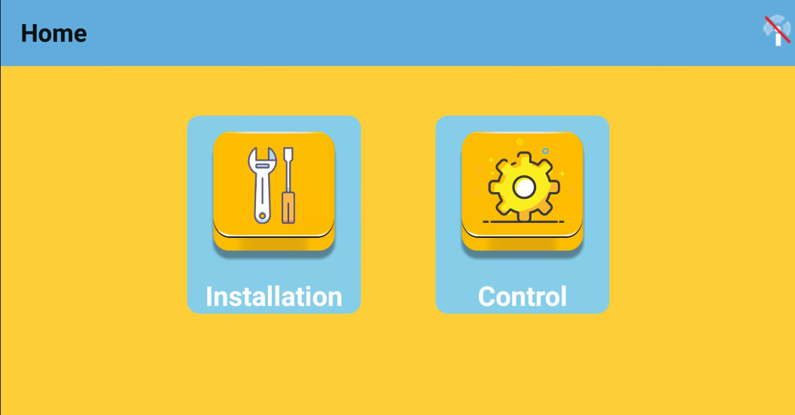

2.2 Click the icon in the top right corner to connect to Bluetooth. Connect automatically connect when close to the robot.

If it is not connected, you can click “**Search Bluetooth**” at the top of the screen to connect.

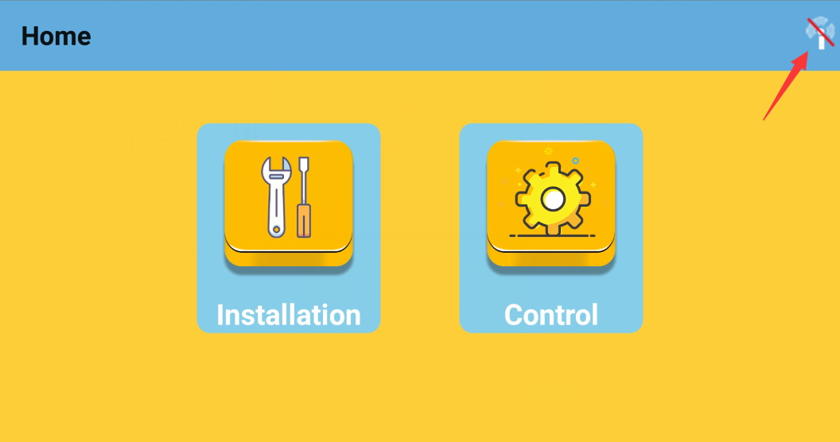

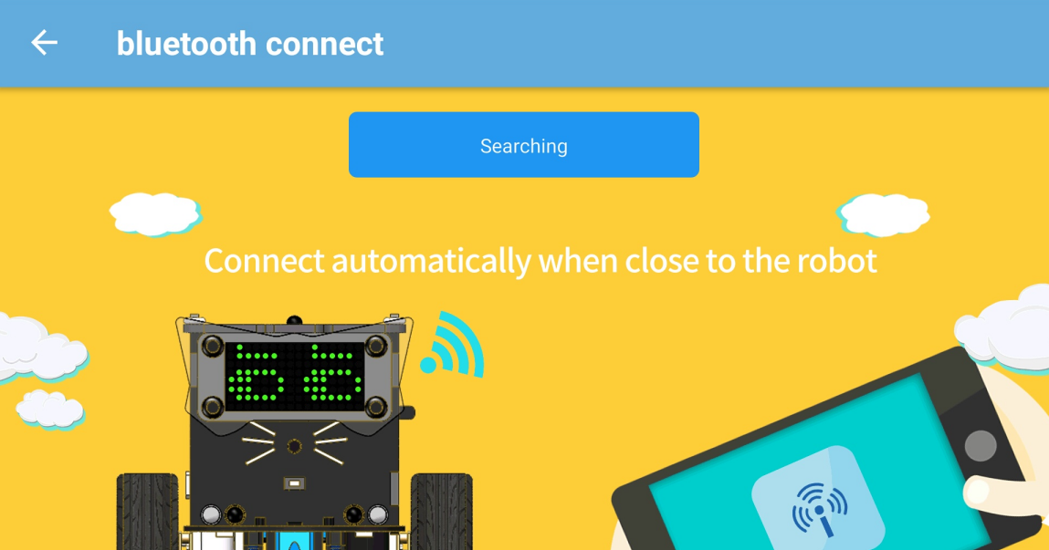

After connecting, the APP will jump to the interface as shown below.

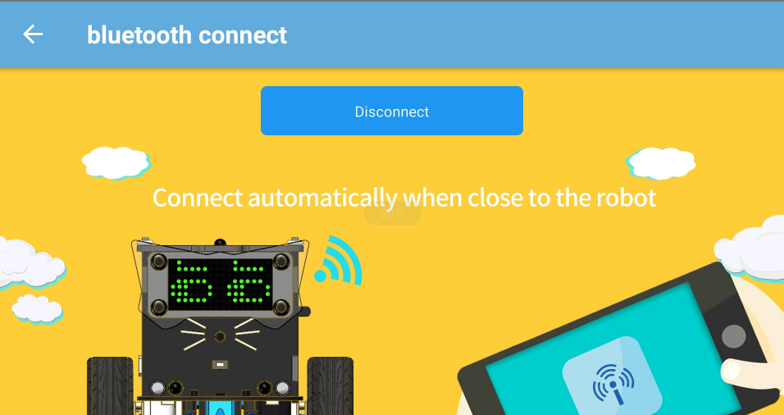

2.3 Next, you can back to the APP homepage. You will see the APP interface as shown below.

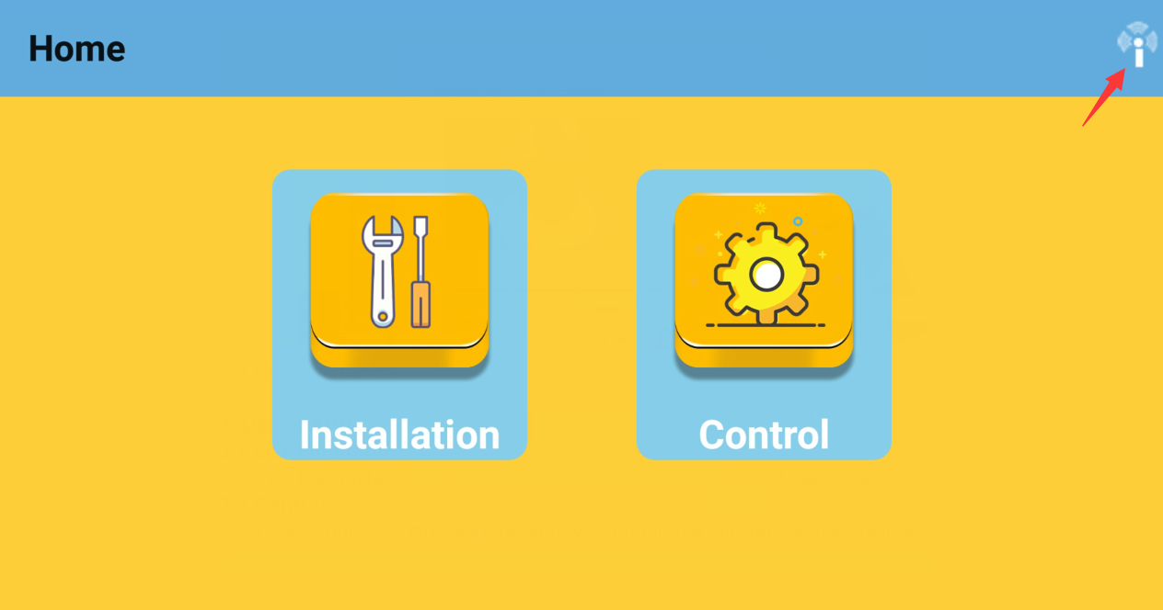

**3. Use of APP**

**3.1 Learning options**

Click on the "Installation" button to view the assembly steps of the robot.

**3.2 Contro**l

Click the “Control” button and the APP will jump to the interface shown below.

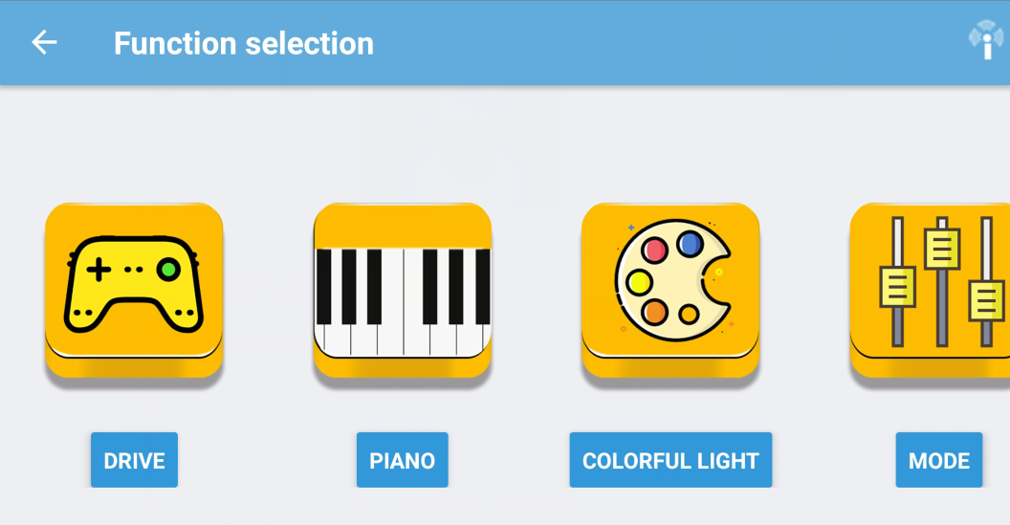

**（1）Drive**

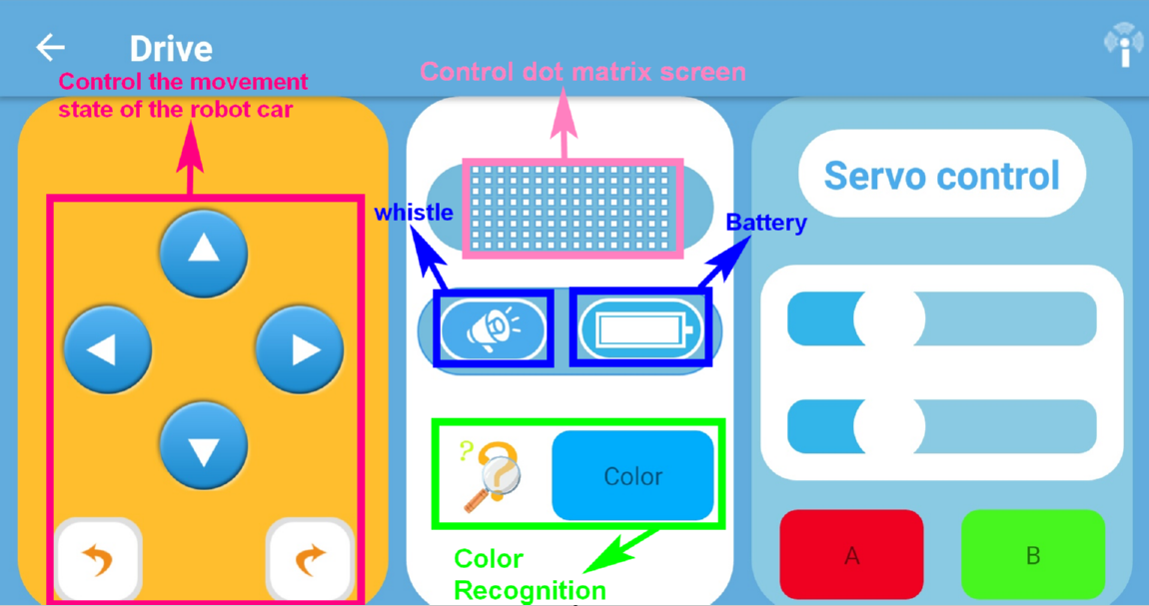

The left side is the button that control the robot to advance, back, turn left, turn right, spin left, and spin right;

The middle is to control the dot matrix screen, whistle and display the current battery power;

The left side is the button that control the angle of rotation of the robot servo.

(This function needs to be plugged in to the servo to be used)

**About the color recognition:**

**We need to put Omibox robot on the red, blue, green, and white colors of our color track, we can see that the APP shows the corresponding color.**

**!!!Note: These four colors are currently only recognized in here.**

**About the dot matrix display:**

**! ! ! note:**

**When we customize some patterns in the APP interface, the robot's dot matrix screen may not be fully synchronized. In this case, we need to click [Refresh Display] button, then we can see that the robot's dot matrix screen shows the same of picture.**

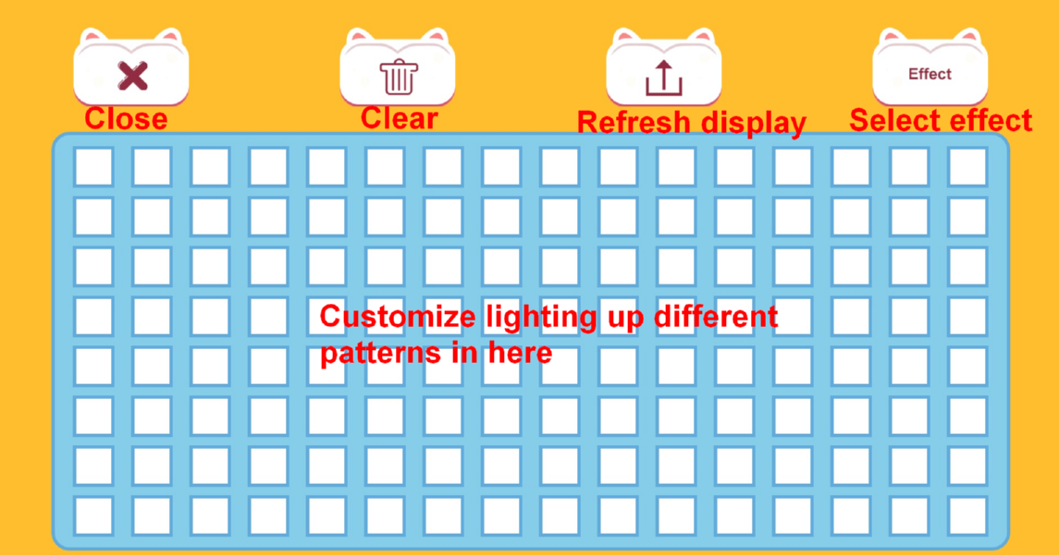

**（2）PAINO**

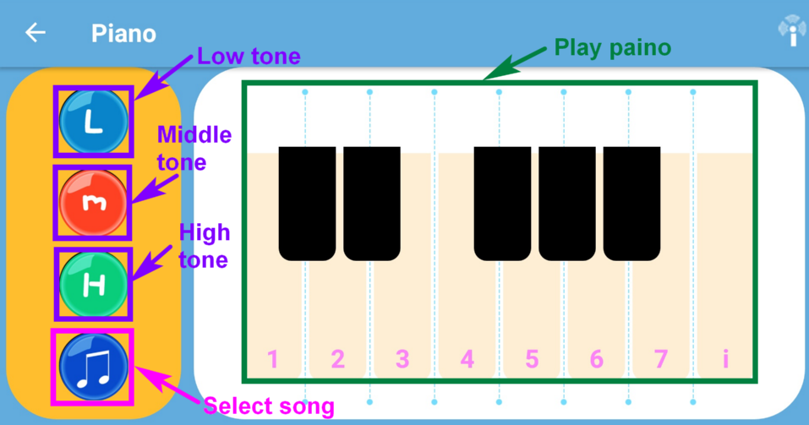

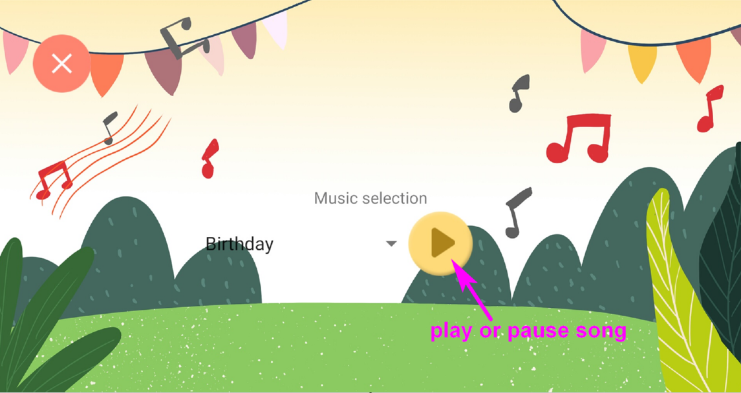

**（2）COLORFUL LIGHT**

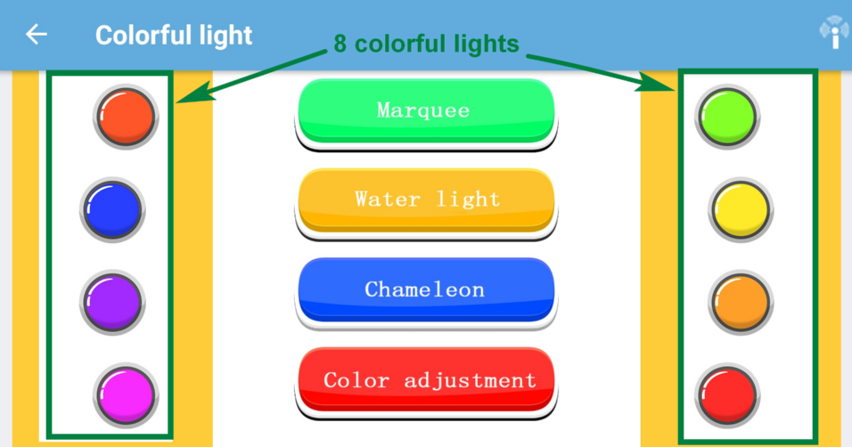

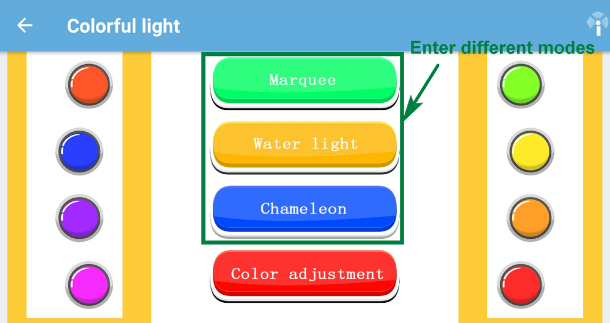

**!!!Note:**

**If you need to control the car to complete other functions, you must exit these modes.**

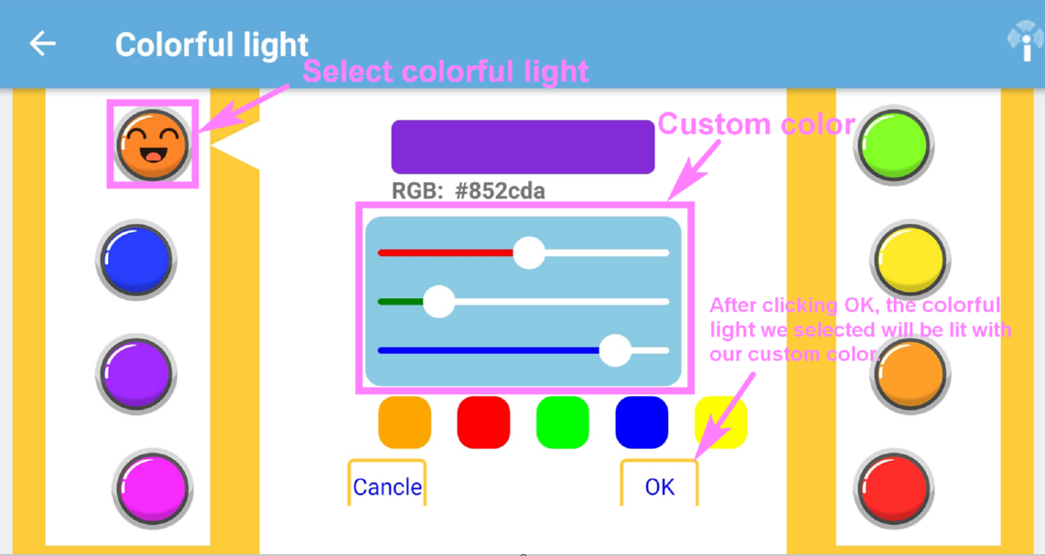

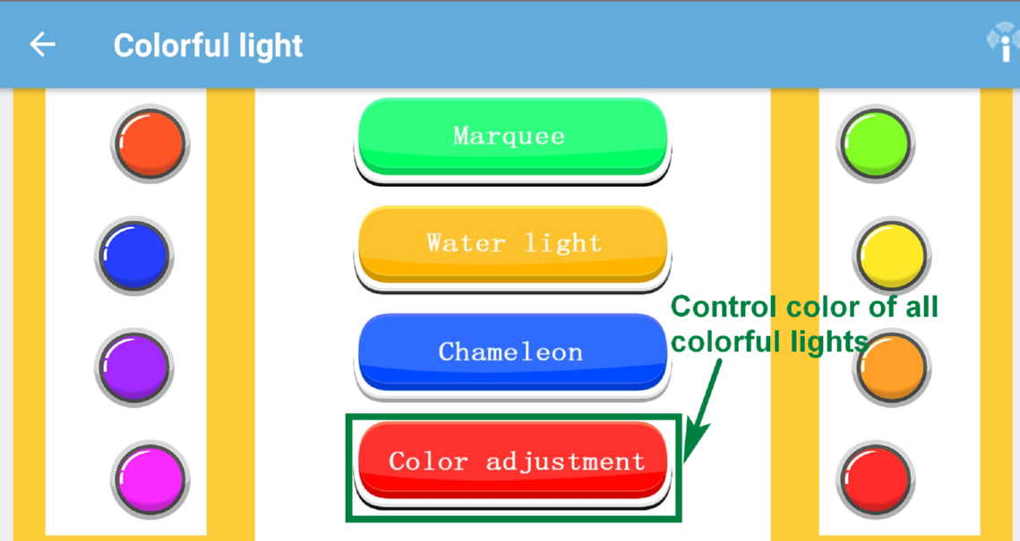

**（4）MODE**

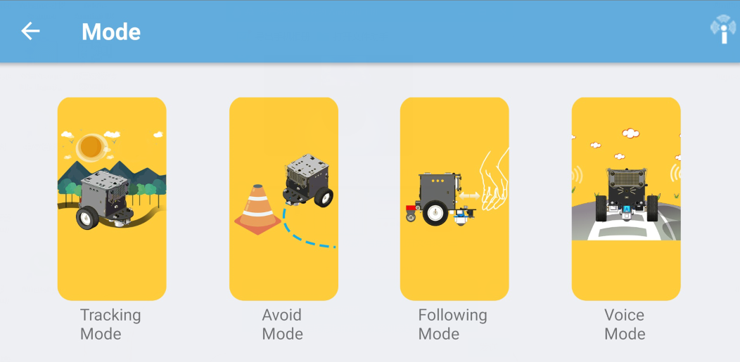

**!!!Note:**

**If you need to control the car to complete other functions, you must exit these modes.**

**Tracking mode:**

Put the robot on the black line of the track, then click on the 【Tracking mode】 and the robot start tracking. Exit this mode until you click on the 【Tracking mode】 again.

**Avoid Mode:**

Click on 【Avoid Mode】, the robot advances, when encountering obstacles, the robot will spin left . Exit this mode until you click on the 【Avoid Mode】 again.

**Following mode:**

Click 【Following mode】, the robot advances when there is an obstacle on the current side. Exit this mode until you click on the 【Following mode】again.

**Voice Mode:**

Click 【Voice Mode**】**. When you take a breath at the sound sensor or make a loud sound, the buzzer will sound and the dot matrix will display an “x”. The robot will advance. Exit this mode until you click on the 【Voice Mode】again.